**Day-7 session-7(20/08/2024)  
----------------------------------------  
Step-1:** connecting to the server

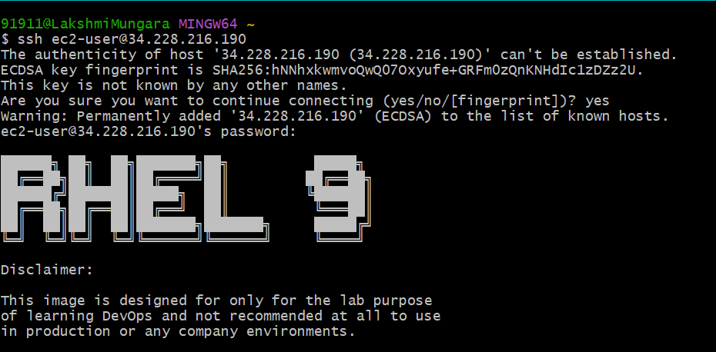

* Go to root and install the mysql-server by using dnf install mysql-server –y

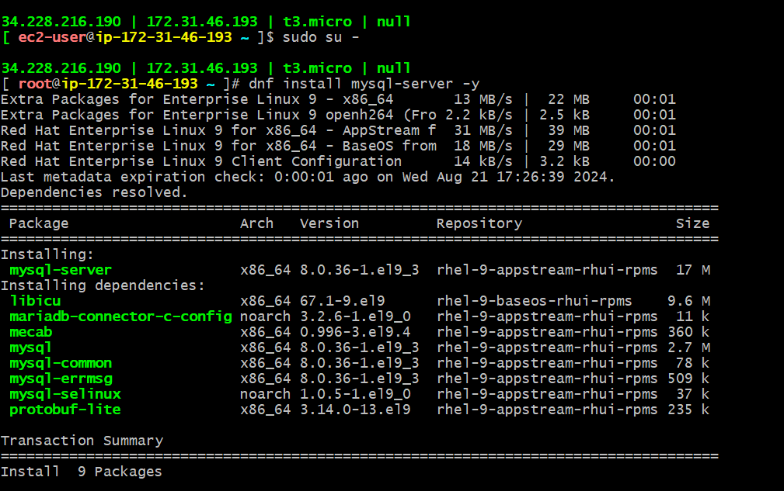

* Enable the mysql package

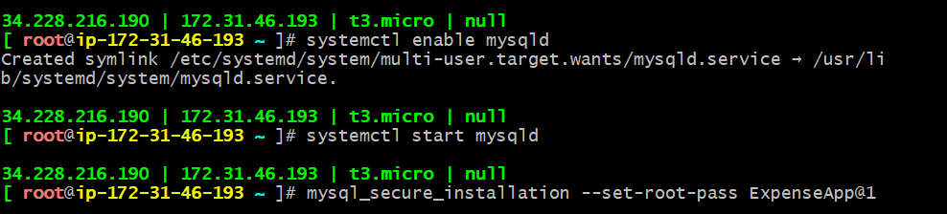

* Check the mysql status

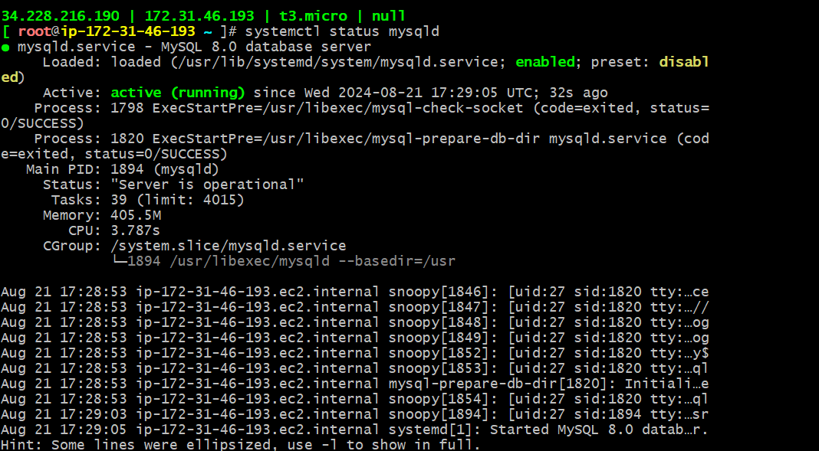

* Check if the port number is opened or not

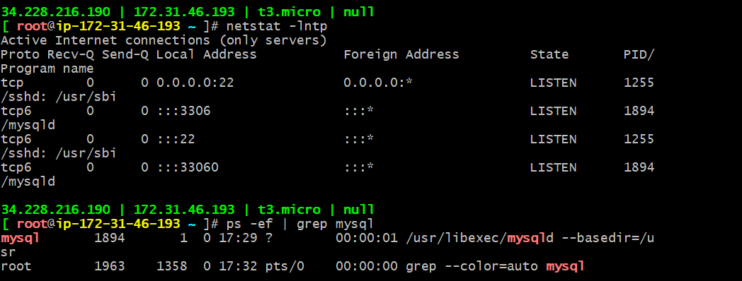

* Open mysql, display the databases, use any of the databases, show the tables and select any of the table

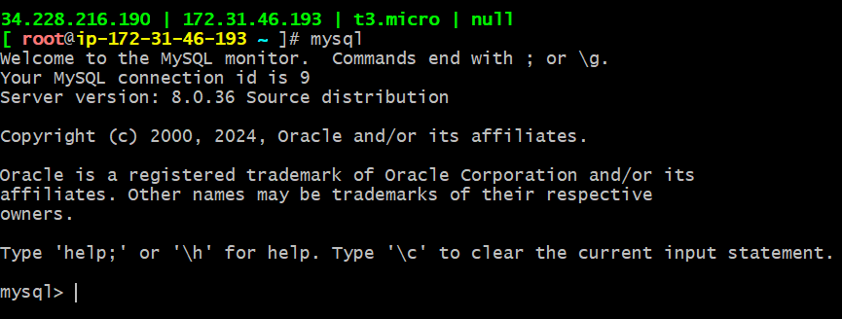

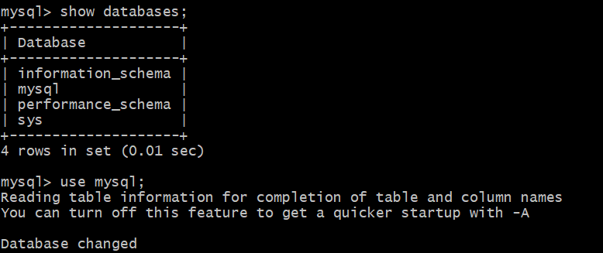

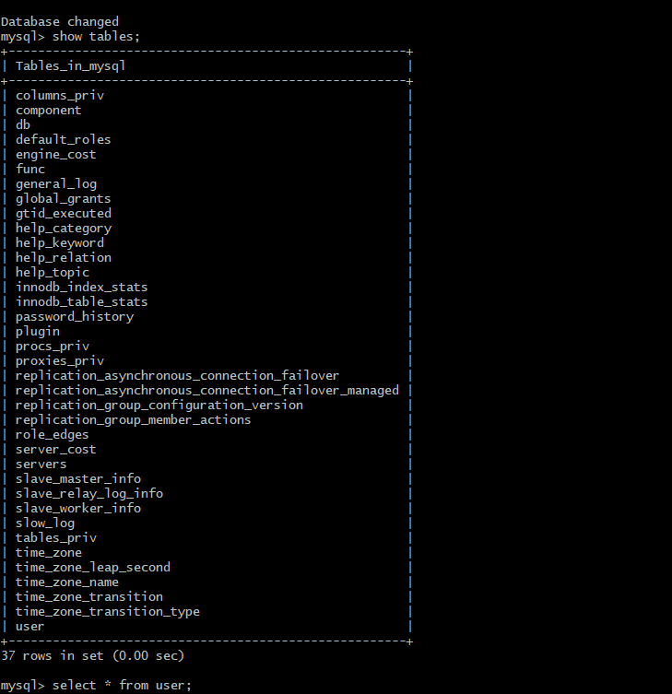

* Process to install Putty and change the settings in it

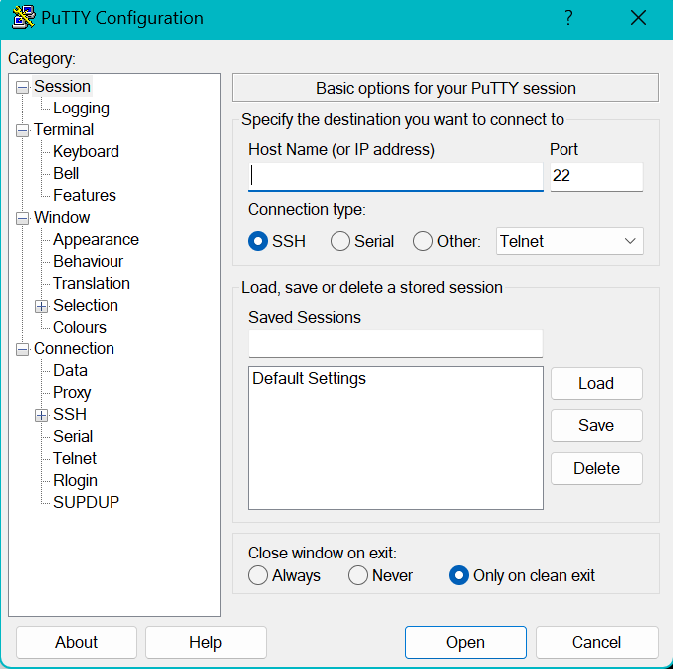

* Create a session called daws-81s

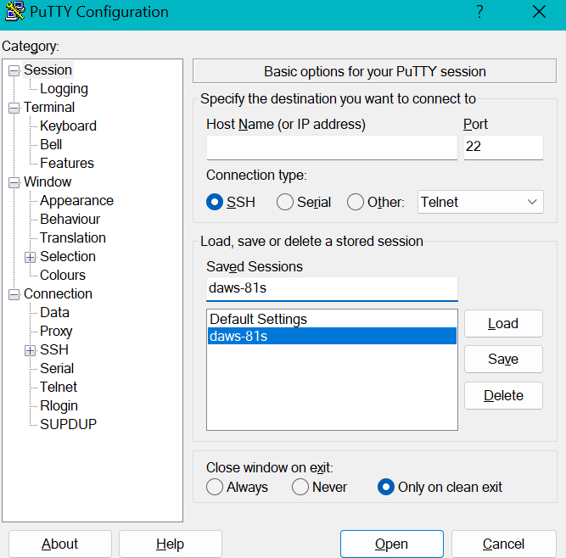

* Go to Data in connection and give the username as ec2-user

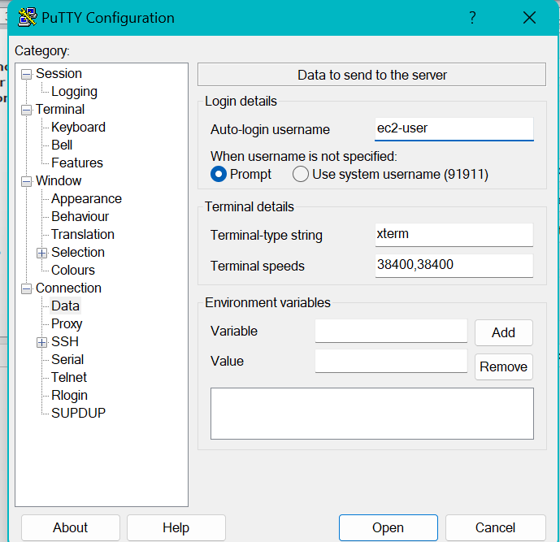

* Change the appearance if wanted

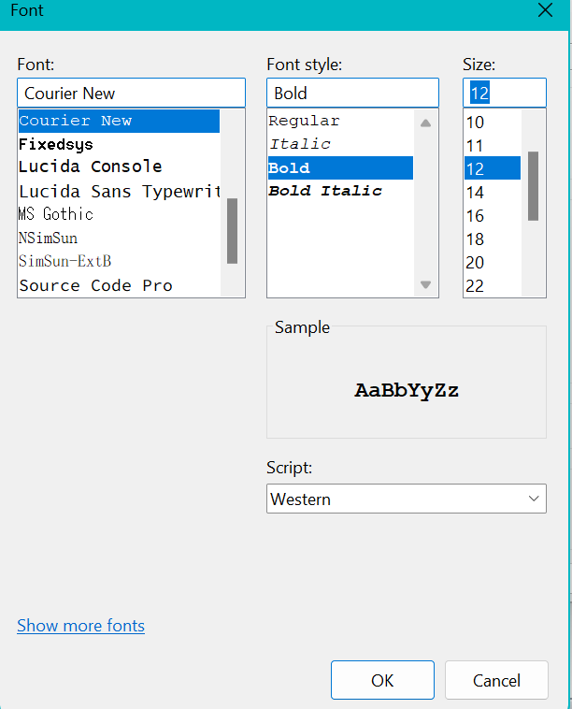

* Give the Public IP address of the instances which was created

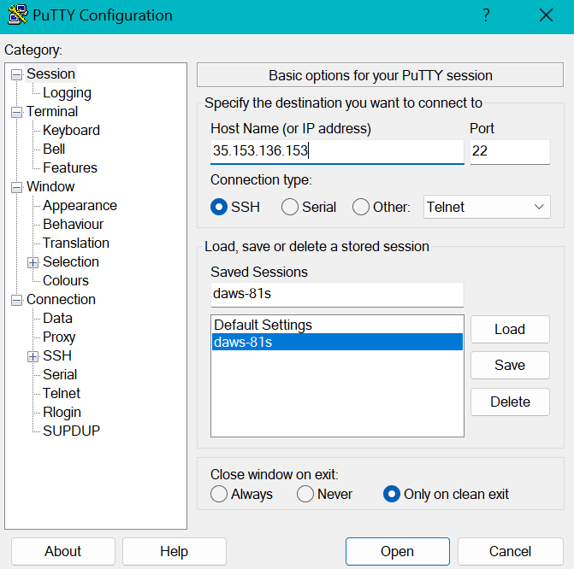

* Connect to the database server with the,   
  username: ec2-user and password: DevOps321

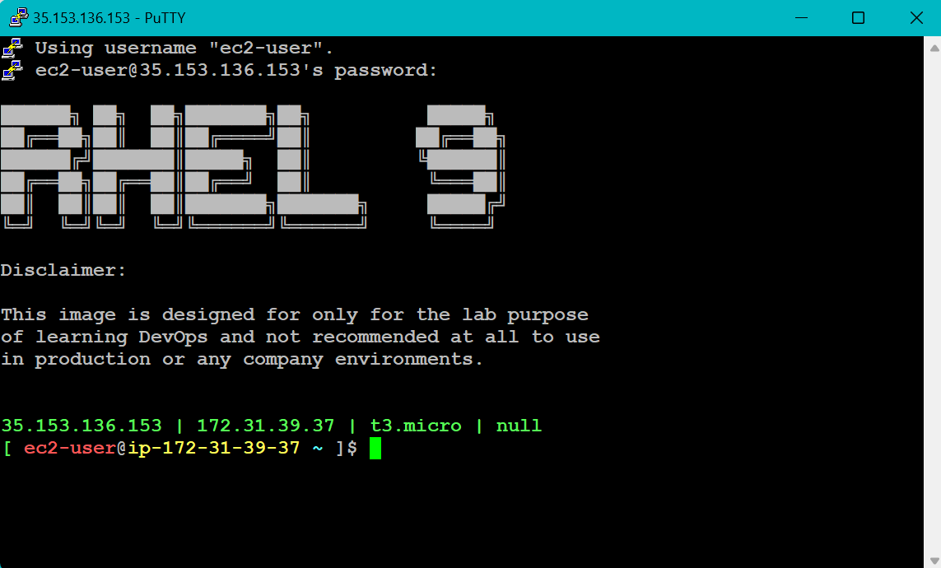

* Process to install superPutty

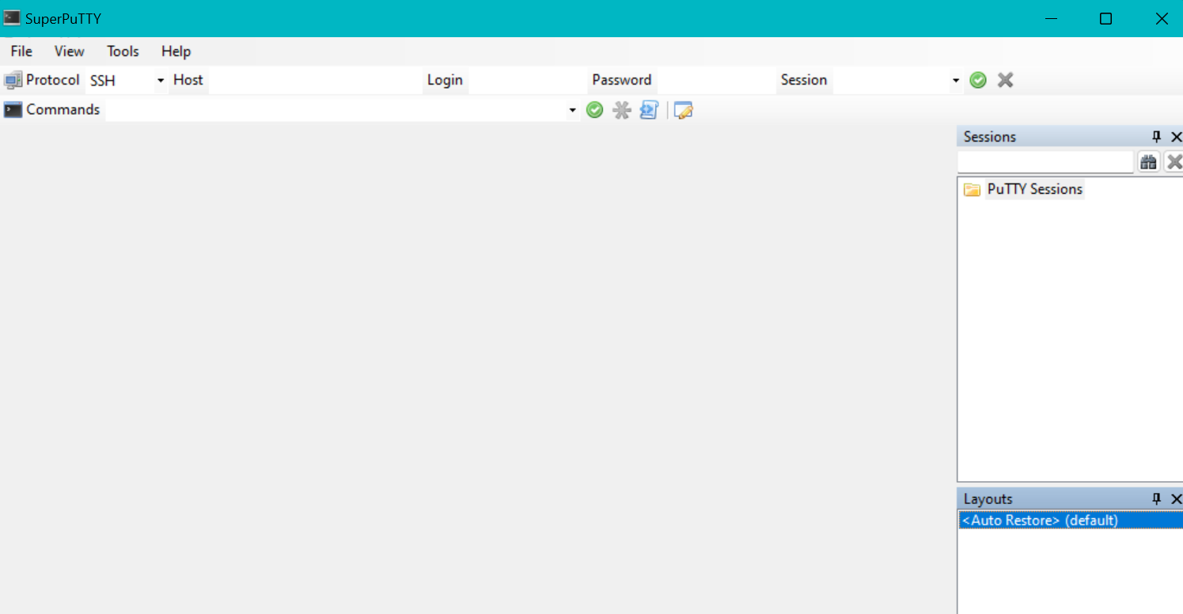

* Connect to the backend-server instance

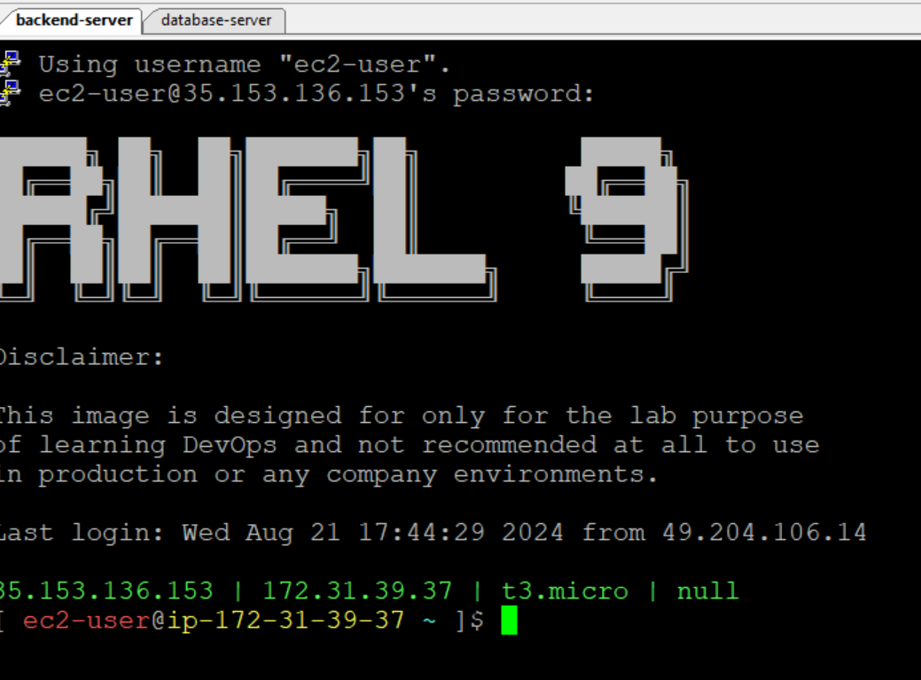

* Go to root, Display the list of modules which are available

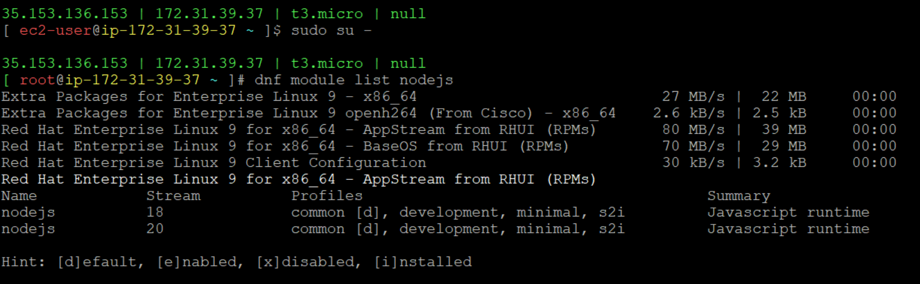

* Disable the version 18 of nodejs

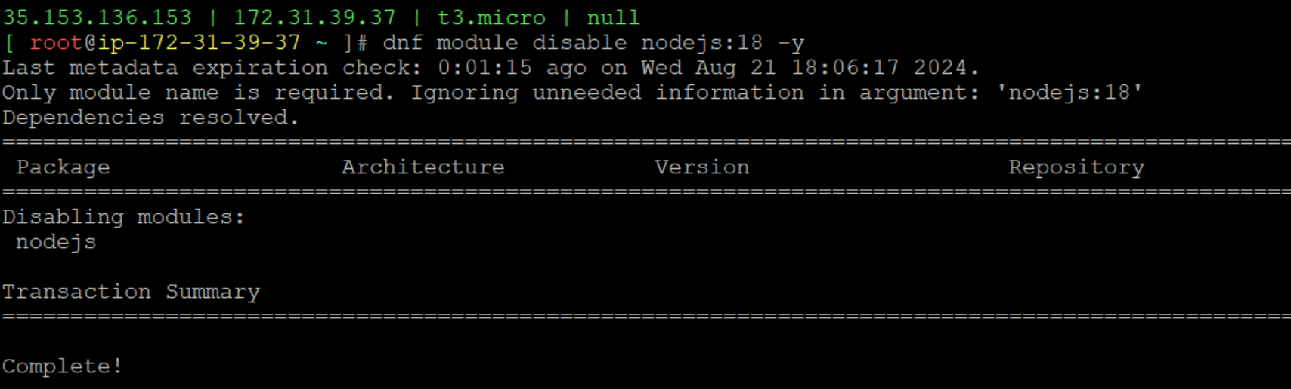

* Enable the version 20 of nodejs

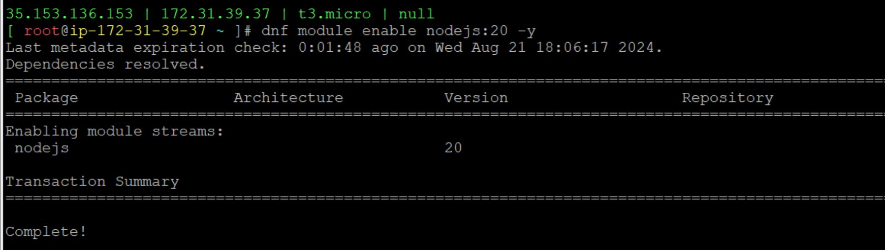

* Install the nodejs package

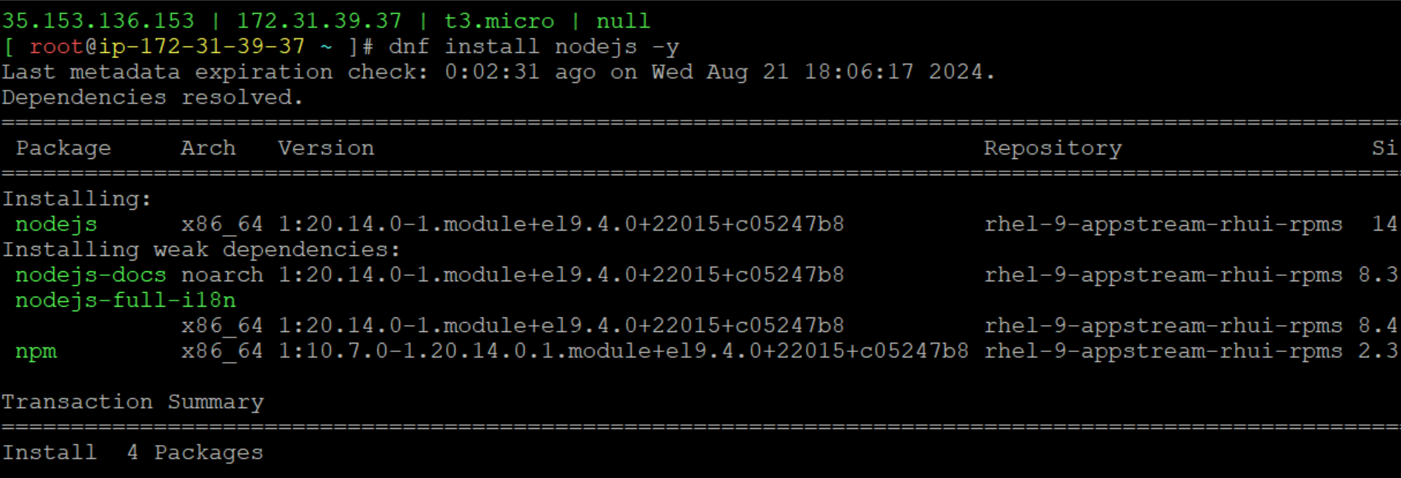

* Add the user called expense and download the expense-backend zip file and store it in /tmp/backend.zip

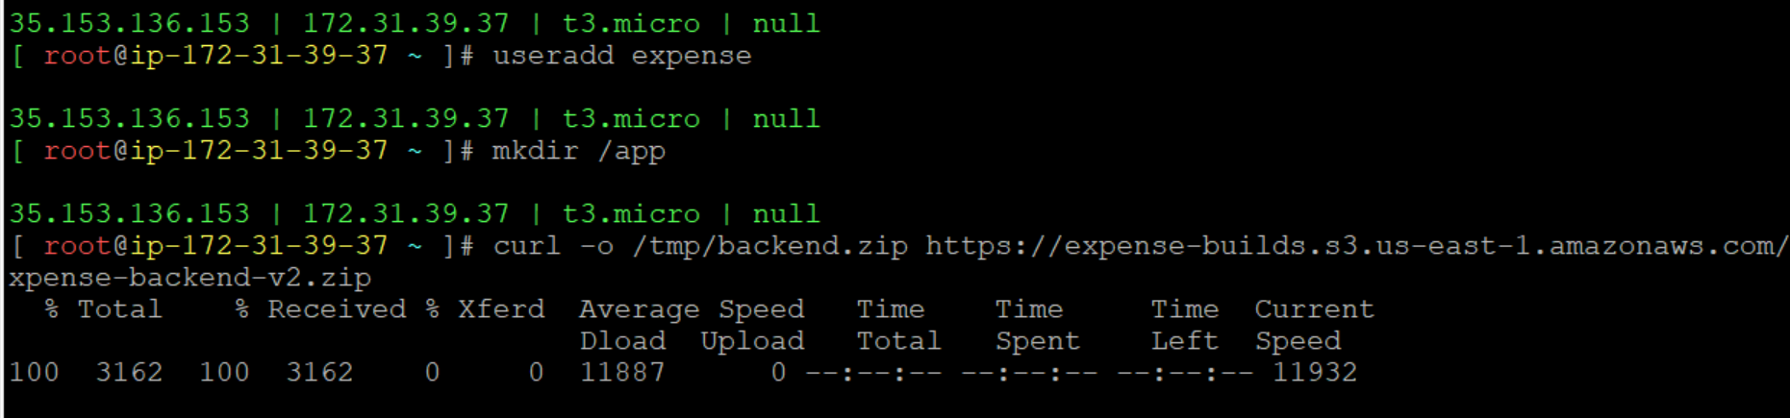

* Change the path to /tmp and list out the files in it

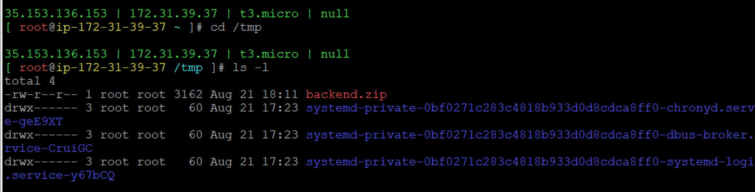

* Go to /app and unzip the backend.zip file

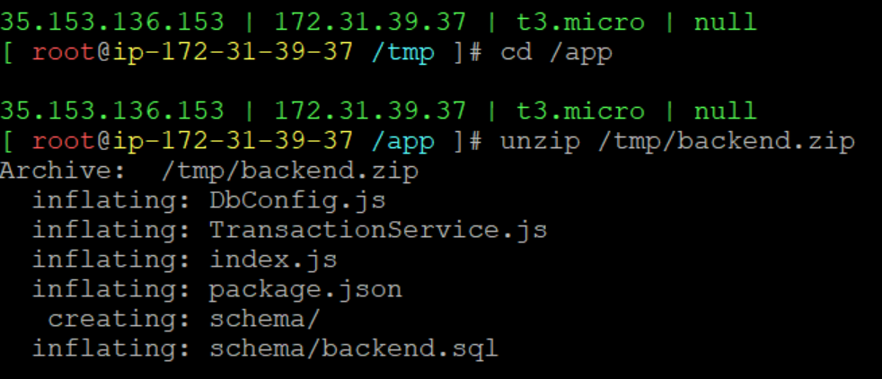

* Display the package.json file

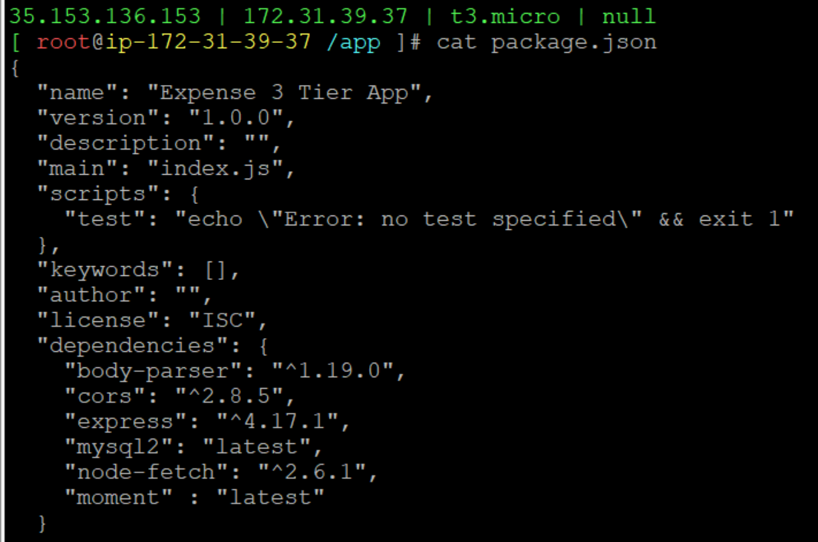

* Install npm packages

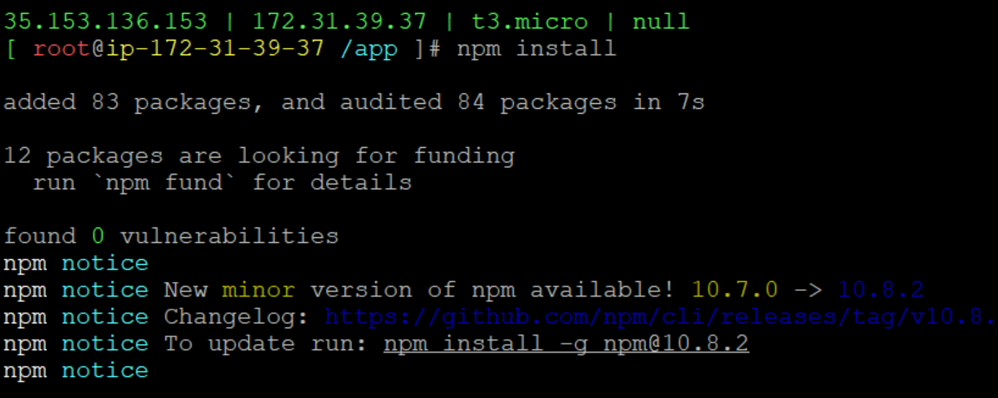

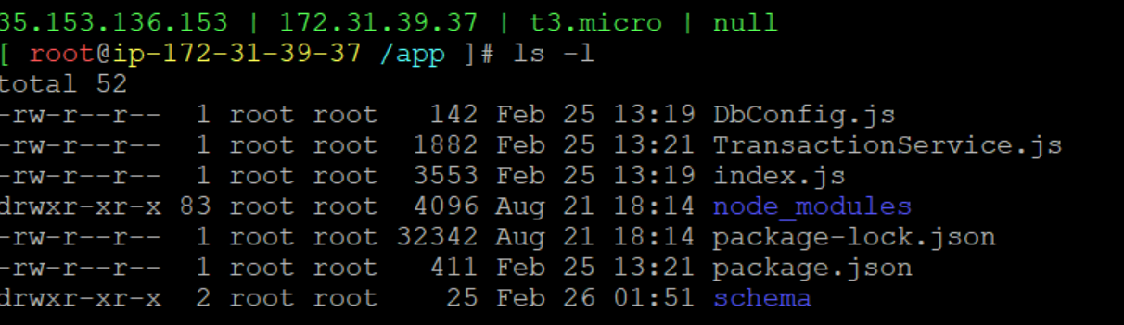

* Open the backend.service. Give the private address of database-server



* Reload the backend, start it and enable it

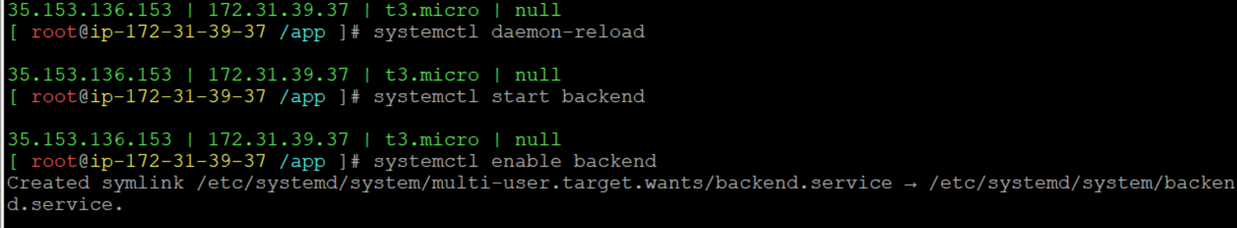

* Check the success and failed messages by using less /var/log/messages command



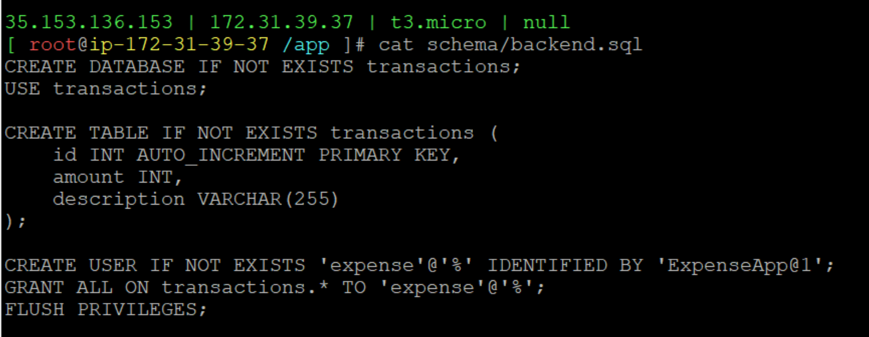

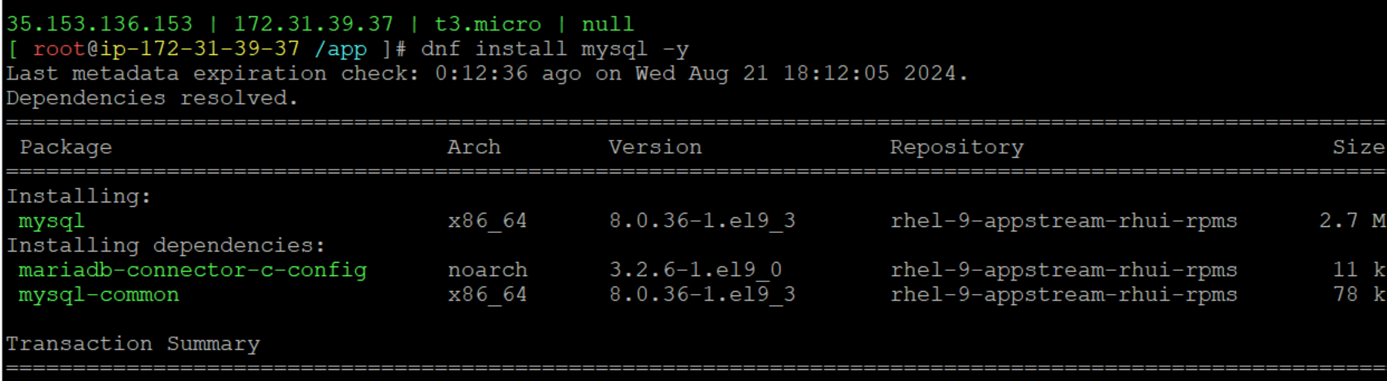

* Give the private IP address of database, use the password(ExpenseApp@1) and add backend.sql file



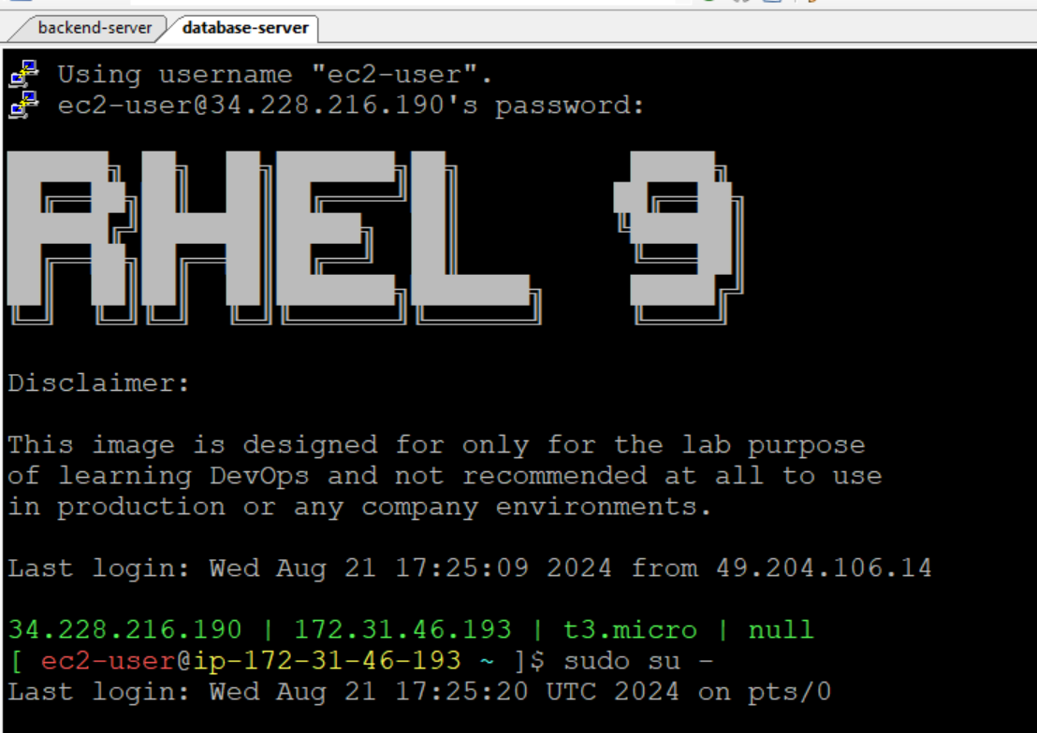

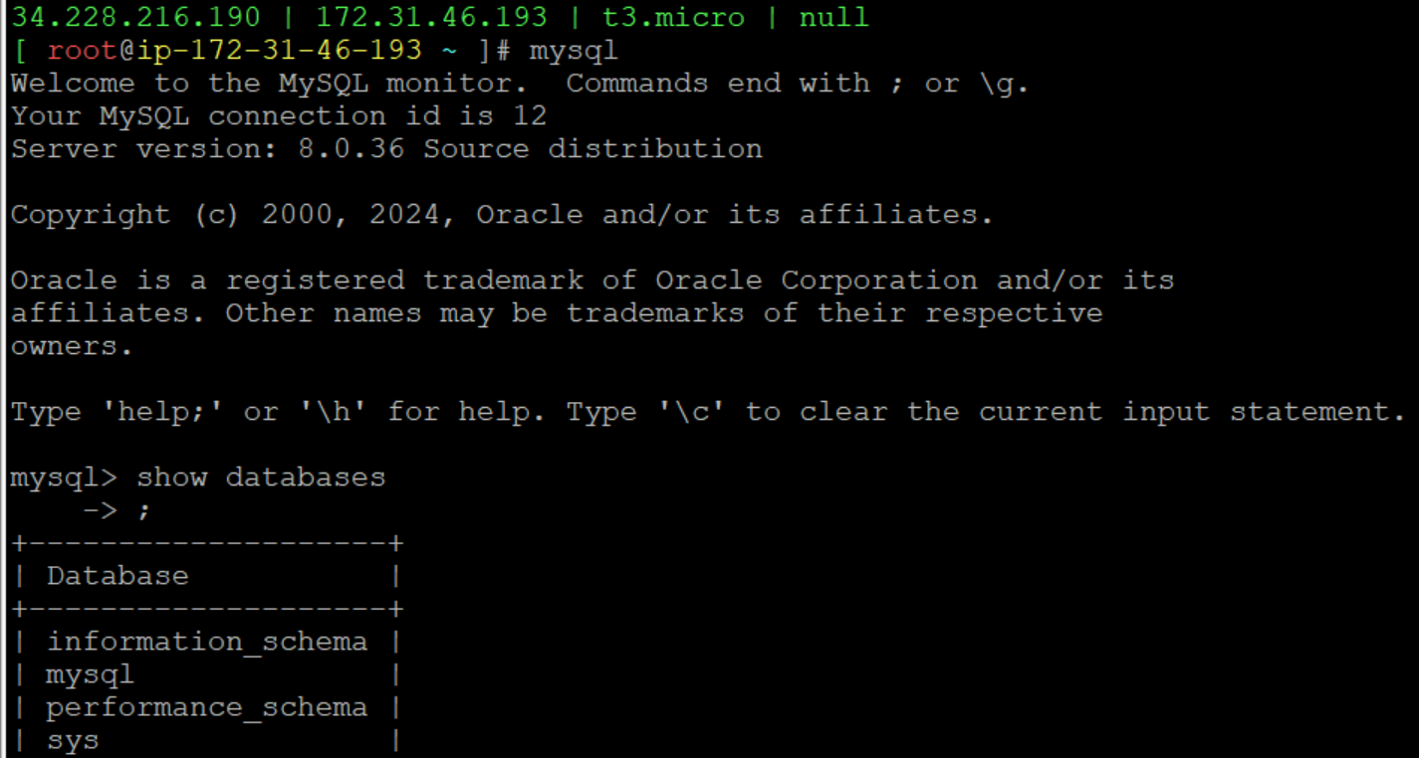

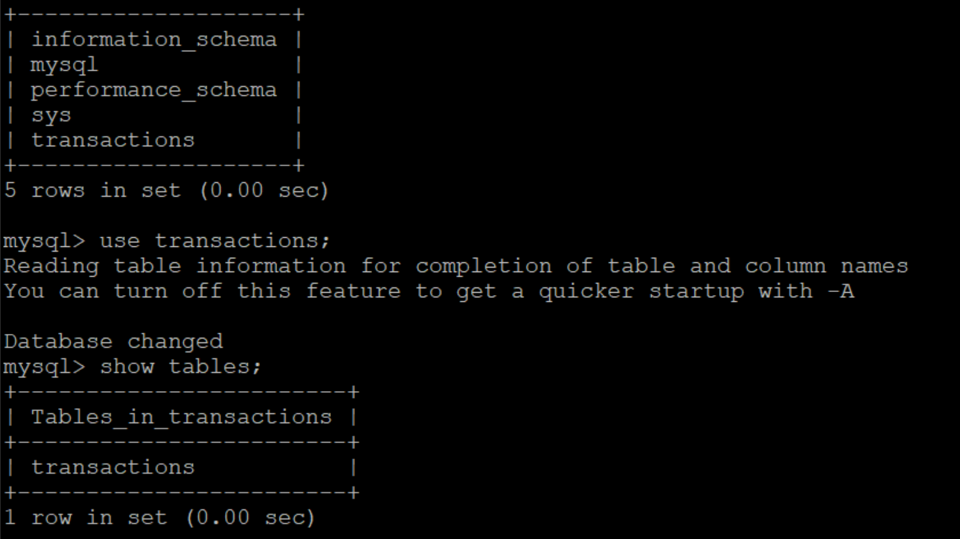

* We can also connect the database in the backend-server by using root password which is shown below

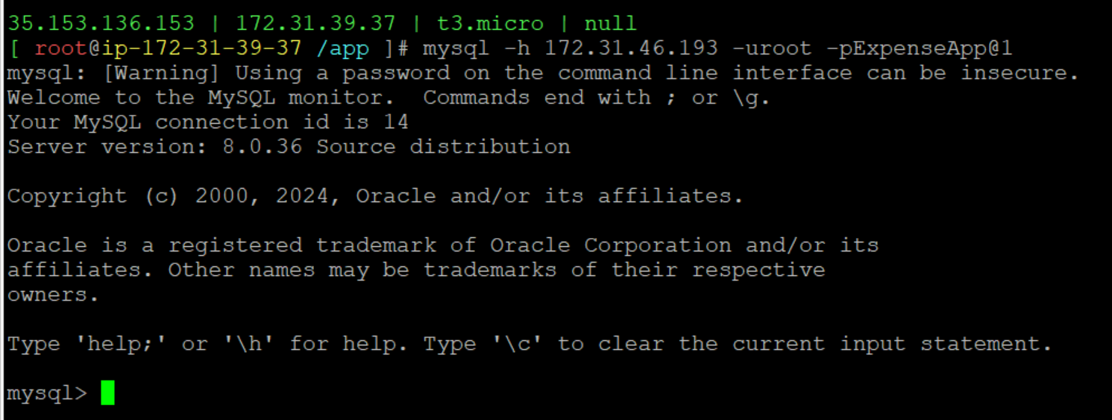

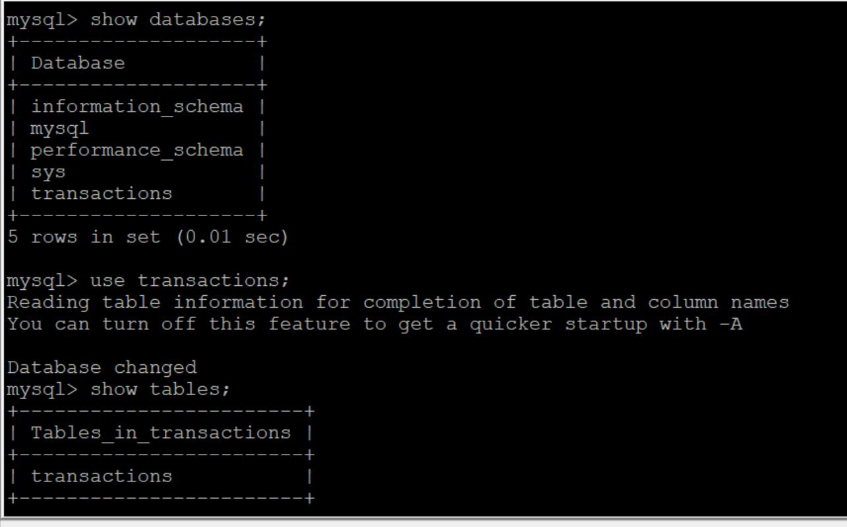

* Restart the backend and check the status of the backend

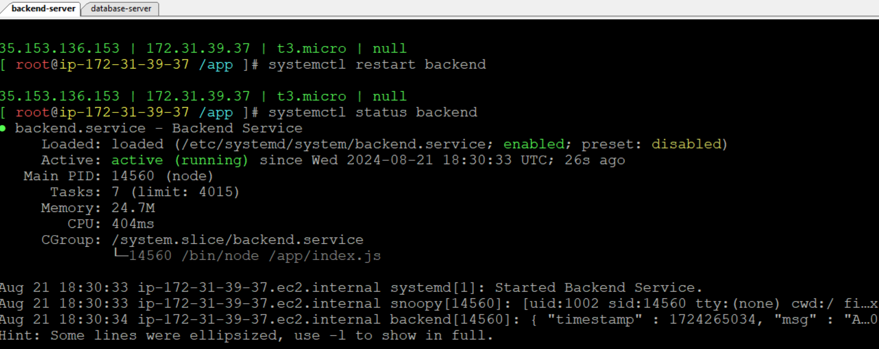

* Check the port numbers are opened or not

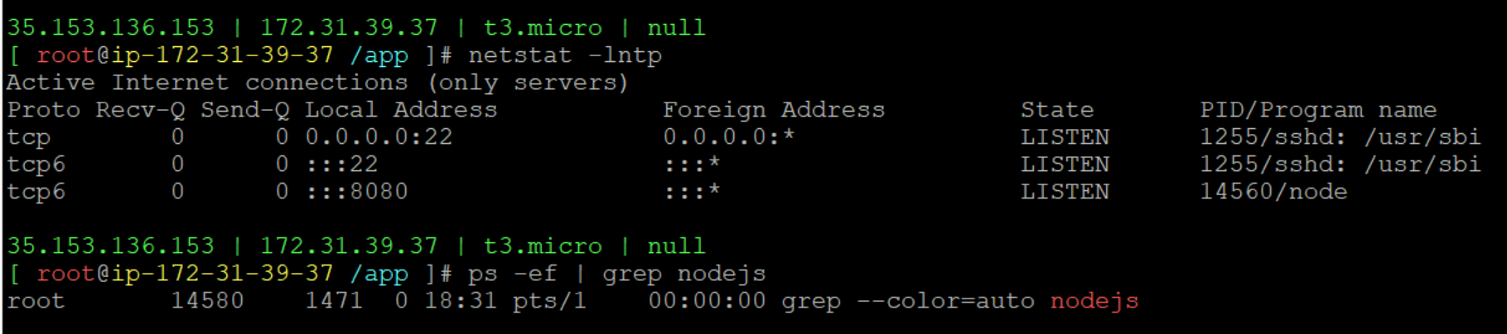

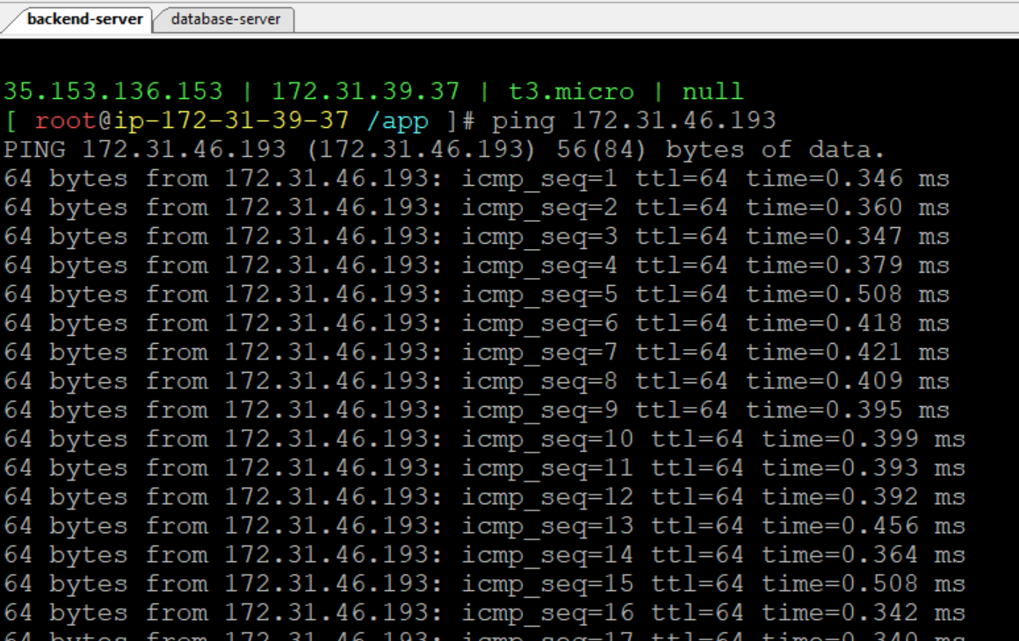

* telnet is the command which shows that it connected to the port number of the database with the help of database private IP

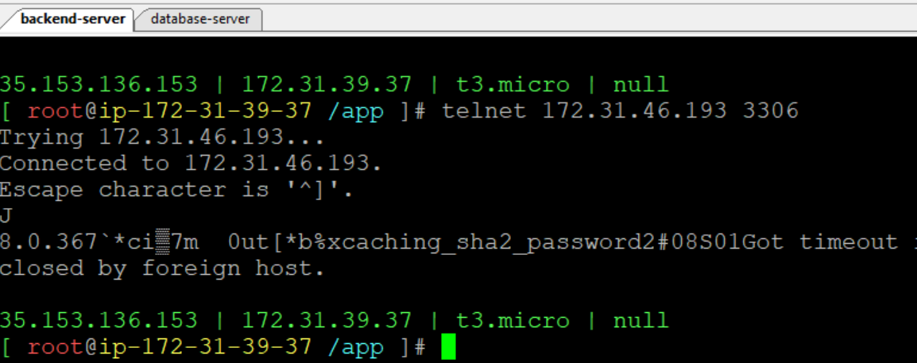

* Connect to the frontend server

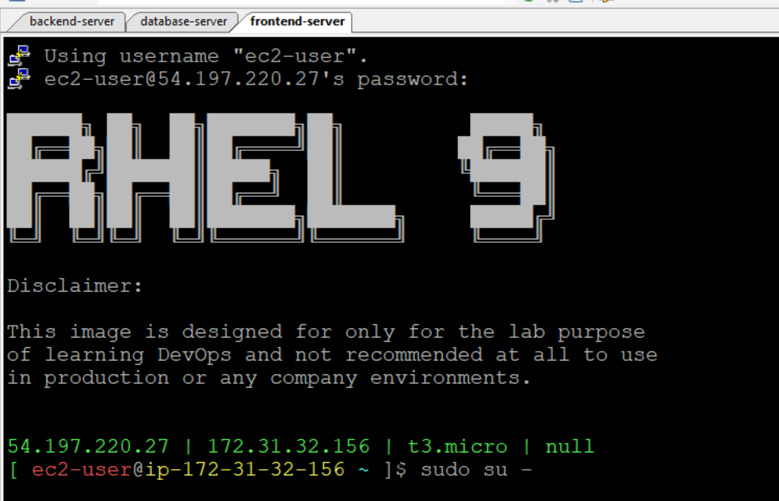

* Install nginx by using dnf install nginx -y

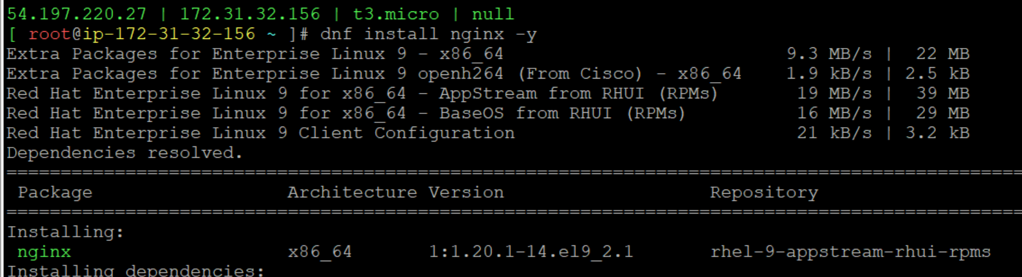

* Start the nginx

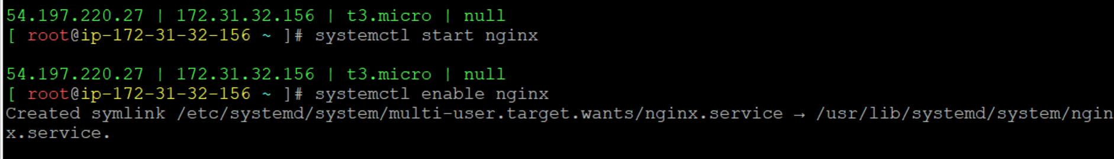

* Go to /usr/share/nginx/html/

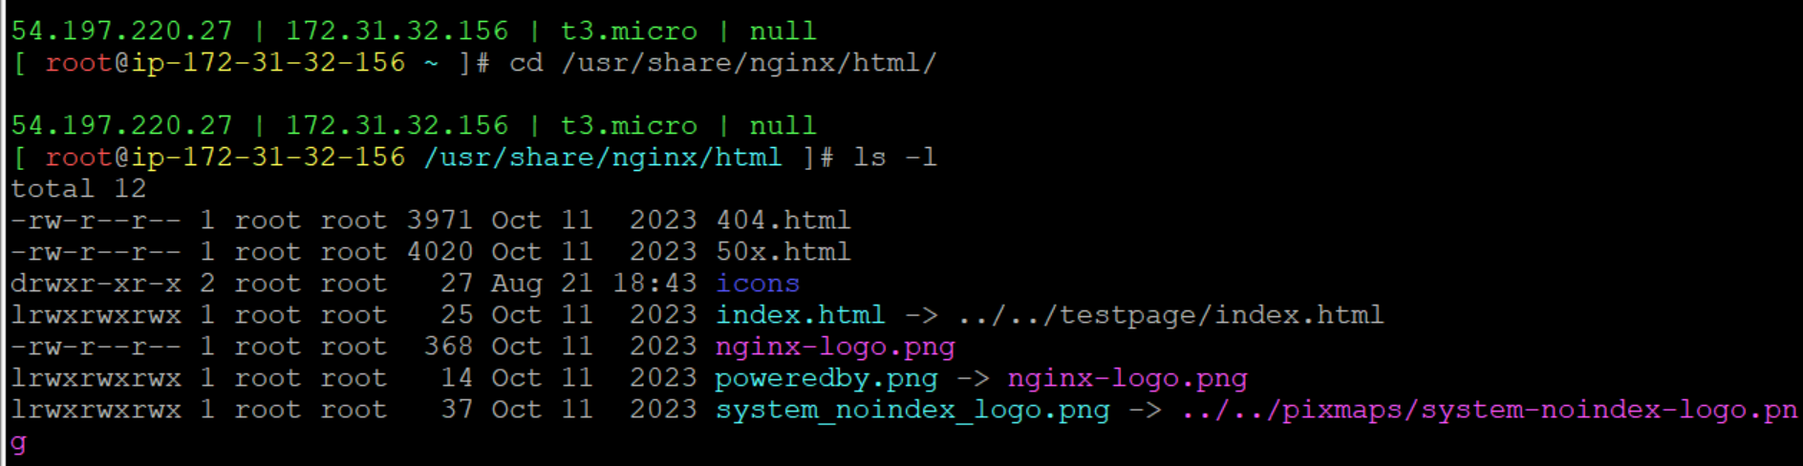

* Remove all the files by using rm –rf \*

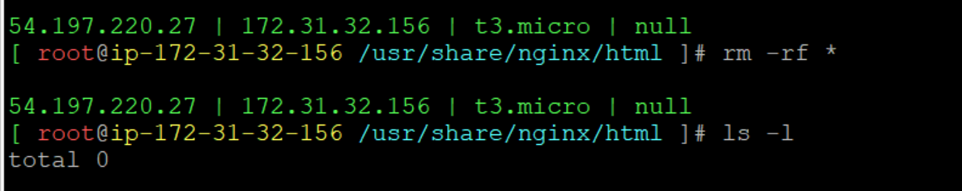

* Remove all the files in the location /usr/share/nginx/html/
* Download the expense frontend zip file and store it into /tmp/frontend.zip

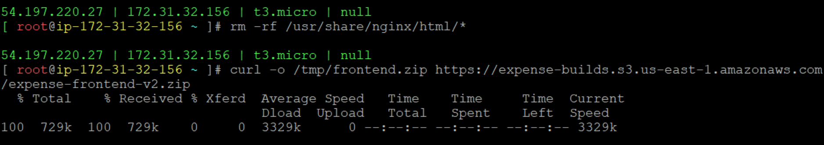

* Unzip the files in frontend.zip

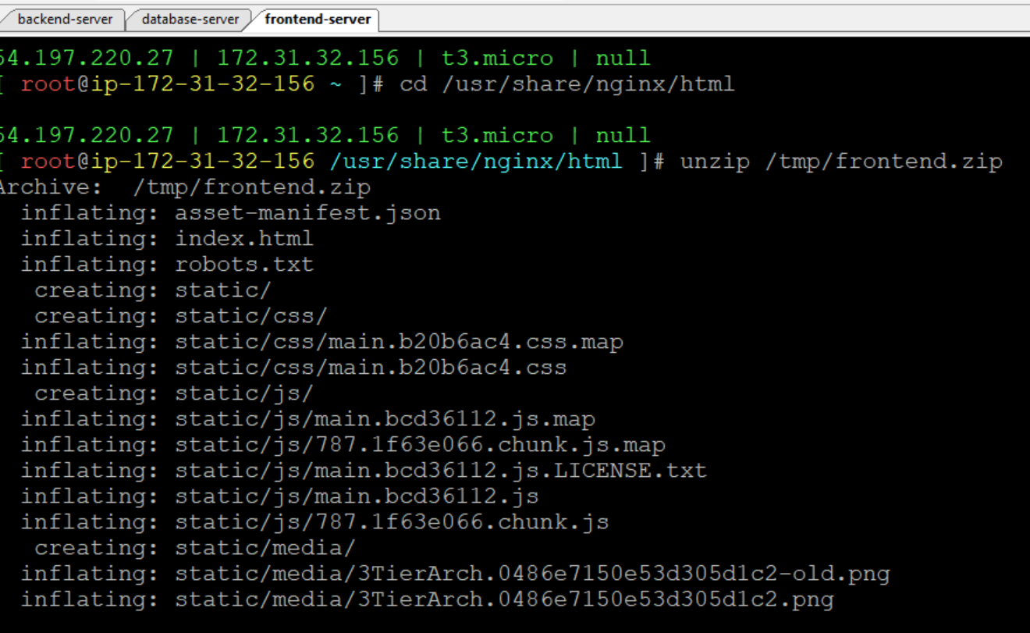

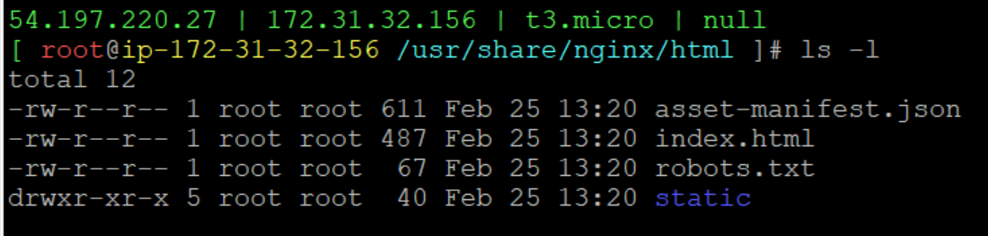

* Open the expense.conf replace the localhost with the private IP address of backend-server



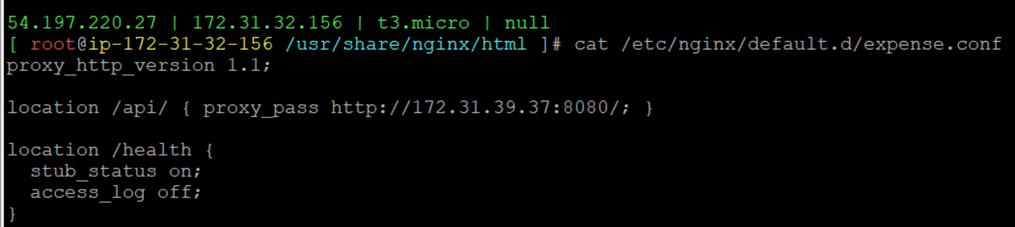

* Restart the nginx



* After restarting, Copy the public IP address of frontend-server and paste it in the chrome or any browser

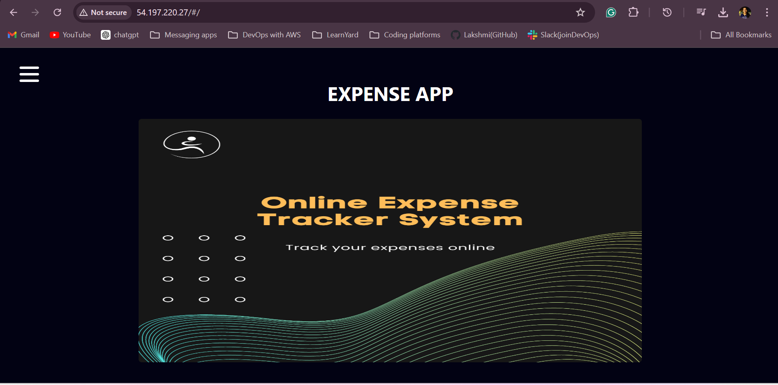

* Enter the amount and desc values

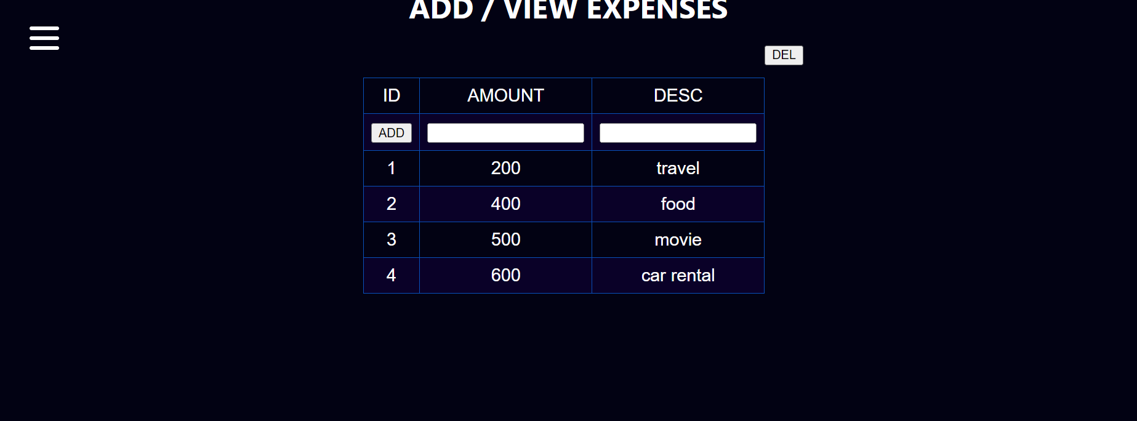

* We can display the data in the database-server which was entered earlier

